GRADIENT BOOSTING MODEL SACCO CREDIT RISK

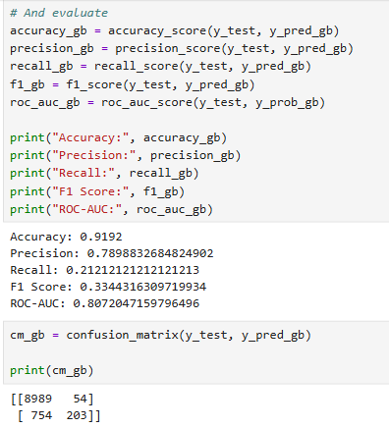

COMPARE THE TWO MODELS WITH BOTH THRESHOLDS AT 0.50

Metric | Logistic Regression | Gradient Boosting
Accuracy | 71.79% | 91.92%
Precision | 20.97% | 78.99%
Recall | 70.32% | 21.21%
F1 | 32.30% | 33.44%
ROC-AUC | 0.781 | 0.807

ROC-AUC
-- The most important result is Gradient Boosting has the higher ROC-AUC: 0.807 vs 0.781. So, based on ROC-AUC, Gradient Boosting is currently separating default/non-default cases better.
RECALL
-- Logistic Regression → 70.32%
-- Gradient Boosting → 21.21%
-- Gradient Boosting is missing many actual defaulters at the default 0.50 threshold.
-- The model is extremely conservative about labeling someone a default.Only 203 of the 957 actual defaults were identified.That's why recall is only about 21.2%.

ACCURACY.
-- Gradient Boosting accuracy so high. This is a great example of why we shouldn't rely on accuracy.
-- Your test set contains 9,043 non-defaults(8989 + 54) and 957 defaults(754 + 203)
-- The Gradient Boosting model correctly identifies 8,989 non-defaults, while making very few false-positive predictions.That produces 91.92% accuracy.
-- But it misses 754 actual defaults. For a credit-risk application, that could be a serious issue.
PRECISION
-- Gradient Boosting has Precision = 78.99% meaning Of the borrowers the model predicted as defaults(257), about 79%(203) actually defaulted.
-- That's substantially better than Logistic Regression's 20.97%.

-- So we now have an interesting trade-off
- Logistic Regression: High recall, Low precision. It catches more risky borrowers but flags many borrowers who don't default.
- Gradient Boosting: Low recall, High precision. When it flags someone as risky, it's usually correct—but it misses many actual defaulters.
THRESHOLDS
-- This is exactly why we shouldn't compare the models only at the default threshold of 0.50.
-- we should test different thresholds for Gradient Boosting, just as we did for Logistic Regression.
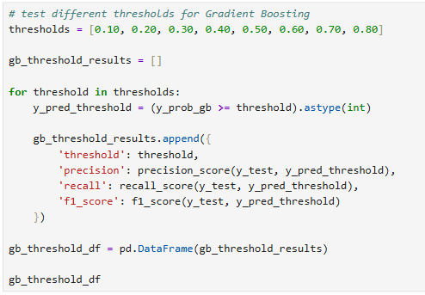
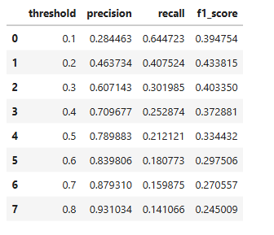
THEN FIND THE HIGHEST F1 AMONG THOSE THRESHOLDS
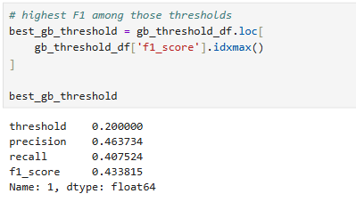

-- So among the thresholds tested 0.20 produced the highest F1 score: 43.38%. That's an improvement over the Logistic Regression's best tested F1 of 38.15%.

COMPARING OUR TWO MODELS USING THE BEST F1 THRESHOLD WE TESTED.
 | Logistic Regression | Gradient Boosting
ROC-AUC | 0.781 | 0.807
Best tested F1 | 0.381 | 0.434
Best tested threshold | 0.70 | 0.20
Precision at that threshold | 35.77% | 46.37%
Recall at that threshold | 40.86% | 40.75%

-- At their respective highest-tested-F1 thresholds, Gradient Boosting has almost the same recall as Logistic Regression but higher precision and F1.
-- The Gradient Boosting model's ROC-AUC = 0.807 is higher than Logistic Regression's ROC-AUC = 0.781
-- So the tree-based model is currently showing better ranking/discrimination as well as a better F1 among the thresholds we tested.
-- However, remember that these thresholds were selected using the test-set results, so we should not present 0.20 as our final production threshold yet. We would normally select/tune the threshold using validation or cross-validation, then evaluate the final model once on an untouched test set.

OUR MODEL COMPARISON IS THEREFORE BECOMING
Logistic Regression
↓
ROC-AUC 0.781
↓
Threshold analysis
↓
Gradient Boosting
↓
ROC-AUC 0.807
↓
Threshold analysis
↓
Compare risk performance

TUNING THE GRADIENT BOOSTING MODEL
-- Before we call a final model, I'd do two things:
- Tune the Gradient Boosting model rather than accepting the default parameters.
- Create a proper model comparison and final evaluation.
-- We'll test parameters such as n_estimators, learning_rate, max_depth and then evaluate whether tuning actually improves ROC-AUC/F1 rather than assuming a more complicated model is automatically better.
-- Our current Gradient Boosting model used:
- n_estimators = 100
- learning_rate = 0.1
- max_depth = 3
-- Those are reasonable starting values, but they are not necessarily optimal for our dataset.
-- We'll let cross-validation search through several combinations using only the training data. The test set remains untouched until the end.
Training data
↓
3-fold cross-validation
↓
Choose best parameters
↓
Train best model
↓
ONE final evaluation
↓
Test data

STEP 1 — SET UP THE PARAMETER GRID
-- We'll test three important parameters:
- n_estimators → number of trees
- learning_rate → how strongly each tree contributes
- max_depth → complexity of each tree
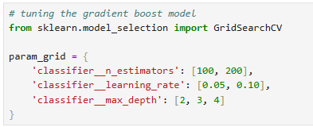
STEP 2 — CREATE THE TUNING SEARCH
-- We'll use ROC-AUC as our optimization metric because we don't want to choose the model based on an arbitrary 0.50 threshold. ROC-AUC evaluates how well the model separates the two classes across thresholds.
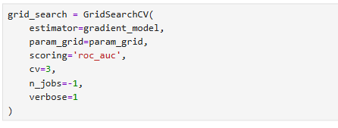
-- What does cv=3 mean? The training data is divided into 3 parts. Conceptually:
Fold 1 → validation
Fold 2 + Fold 3 → training

Fold 2 → validation
Fold 1 + Fold 3 → training

Fold 3 → validation
Fold 1 + Fold 2 → training
-- Each parameter combination gets evaluated three times.
-- This gives us a more reliable estimate than simply training once.
STEP 3 — RUN THE TUNING
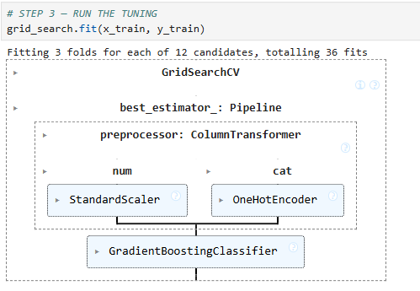
STEP 4 — SEE THE BEST PARAMETERS
-- After it finishes:
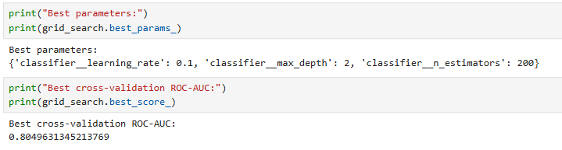

STEP 5 — GET THE TUNED MODEL
-- The best fitted pipeline is available as:
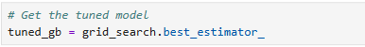
-- Now generate predictions on the test set:
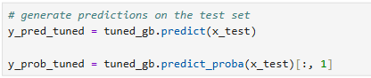
-- Then evaluate:
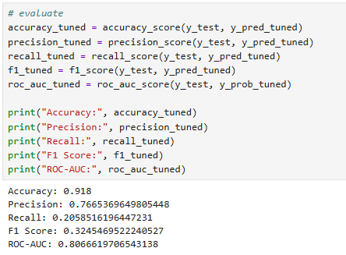
-- And the confusion matrix:
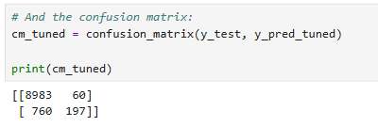

UNTUNED VS TUNED GRADIENT BOOSTING
Metric | Untuned | Tuned
Accuracy | 91.92% | 91.80%
Precision | 78.99% | 76.65%
Recall | 21.21% | 20.59%
F1 | 33.44% | 32.45%
ROC-AUC | 0.8072 | 0.8067

-- The selected parameters were:
- learning_rate = 0.10
- max_depth = 2
- n_estimators = 200

-- The tuned model's test ROC-AUC is 0.80666 while the original was 0.80720. So tuning did not improve the final test ROC-AUC.
-- That's not a failure. In fact, it's a useful portfolio finding: The initial Gradient Boosting configuration already performed about as well as the combinations tested during tuning.
-- Also notice that the best cross-validation ROC-AUC was 0.80496 while the final test ROC-AUC was 0.80666. Those are reasonably close, which doesn't suggest a huge generalization gap.
-- We should NOT keep tuning indefinitely. We could keep trying hundreds of parameter combinations until we find a slightly higher number, but that doesn't necessarily produce a better real-world model.Instead, we now have enough evidence to proceed with the next stage.
THRESHOLD ANALYSIS FOR THE TUNED MODEL.
-- Remember, the tuned model's current 0.50 threshold gives
Precision = 76.65%
Recall = 20.59%
F1 = 32.45%
-- But we previously found that the untuned Gradient Boosting model achieved its highest tested F1 at 0.20. The tuned model may have a different optimal threshold.
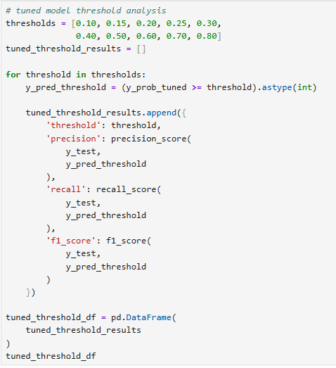
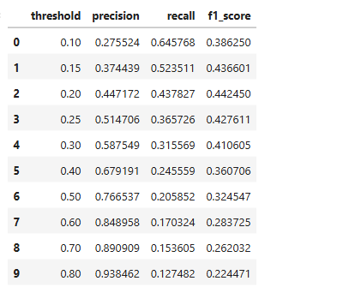
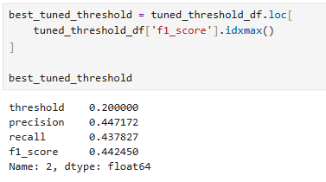
-- So among the thresholds you tested, 0.20 has the highest F1: 44.25%
-- At a 0.20 threshold, the tuned model identifies roughly 44% of actual defaults, while about 45% of the borrowers it flags as defaults actually defaulted.
-- Compared with the Logistic Regression model's best tested threshold:
 | Logistic Regression | Tuned Gradient Boosting
Threshold | 0.70 | 0.20
Precision | 35.77% | 44.72%
Recall | 40.86% | 43.78%
F1 | 38.15% | 44.25%
ROC-AUC | 0.781 | 0.807

-- So our tuned Gradient Boosting model is currently the stronger candidate across these particular metrics.

